|  |  |
| --- | --- |
| Plotting Point | Significance |
| 1 | 0 cm (for measurement calibration) |
| 2 | 1 cm (for measurement calibration) |
| 3 | 2 cm (for measurement calibration) |
| 4 | Upper anterior corner of rectangle circumscribing the calcaneus |
| 5 | Upper posterior corner of rectangle circumscribing the calcaneus |
| 6 | Lower posterior corner of rectangle circumscribing the calcaneus |
| 7 | Lower anterior corner of rectangle circumscribing the calcaneus |
| 8 | Superior anterior point of the anterior process |
| 9 | Apex of the Gissane angle |
| 10 | Summit of the posterior facet |
| 11 | Most posterior point of the calcaneal tuberosity |
| 12 | Insertion of the plantar fascia |
| 13 | Inferior anterior point of the anterior process |
| 14 | Summit of the calcaneal tuberosity |
| 15-35 | Arising slope leading to the summit of the calcaneal tuberosity |
| 36 | Inferior point of the retrocalcaneal tendon-bone contact surface/superior starting point of the Achilles insertion |
| 37-89 | The whole tendon-bone insertion of the Achilles on the calcaneal tuberosity |
| 90 | Weightbearing point |

**Table 1: Significance of the 90 points used for plotting purposes.** 90 points with some of them corresponding to various anatomical landmarks, were plotted on lateral weightbearing radiograph of each calcaneus of the 40 control feet (Figure 1). The (*x,y*) coordinates of these dots were collected to develop a Standard Circle algorithm, with the goal to predict the individual “standard” morphology of any given calcaneus with or without IAT.

**Figure 1. Plotting and mapping the calcaneal tuberosity.** Each calcaneus was circumscribed within a rectangle. Points 4-90 were plotted with some of them representing various anatomical markers, while the rest being evenly distributed between two anatomical markers to map the contour of the bone. (Table 1). Of note, points1-3 were measurement calibration markers and therefore not depicted here.

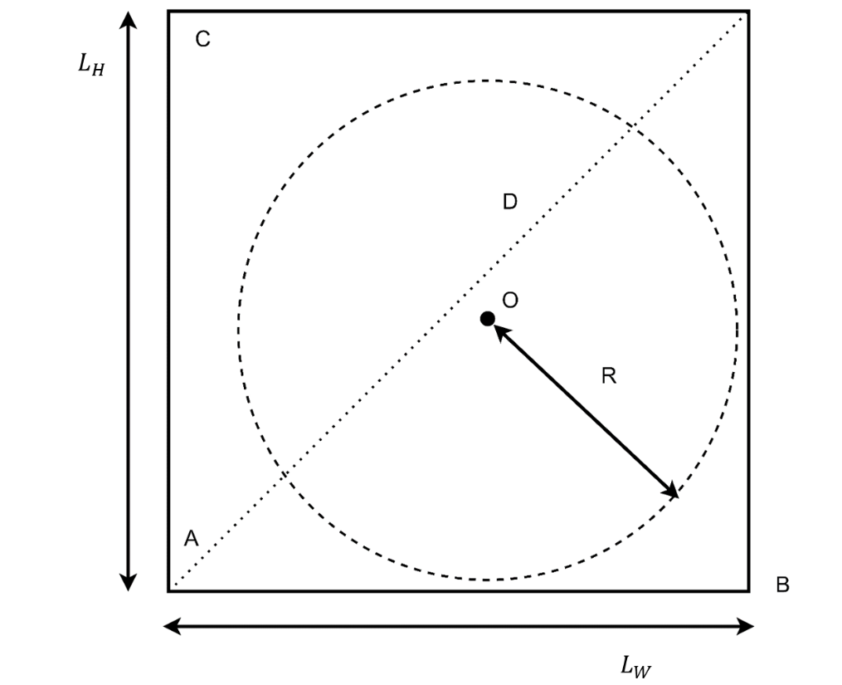

**Figure 2. Schematic denotations for the Standard Circle fitting algorithm.** The fitting algorithm utilized a circular function with the center O and a radius R. The rectangular box circumscribed the calcaneus in each of the control foot and was denoted by width , height , diagonal length D, and corner points A (corresponding to point 7 in Figure 1), B (corresponding to point 6 in Figure 2), and C (corresponding to point 4 in Figure 1).

**Figure 3. Fitted Average Standard Circle.** An average Standard Circle was statistically fitted using plotted calcaneal tuberosities from 40 control calcanei. Green dot clusters represent the preliminarily established anatomical markers (Table 1). Blue dots denote the superior section of the calcaneal tuberosity that is not included in the Achilles insertion. Red dots represent the Achilles insertion section. Every dot has its significance (Table 1) and (*x,y*) coordinates information.



**Figure 4 The Concept of PAIA.** PAIA was developed to both reflectthe degree of enlargement of the calcaneal tuberosity in feet with IAT and represent the angle by which the enlarged calcaneal tuberosity curve can be rotated around the weightbearing point to best fit the ideal contour (Standard Circle) of the individual calcaneus. In Figure 4A, purple dots denote the superior section of the calcaneus, the red dots outline the enlarged calcaneal tuberosity, while green dots represent the realigned calcaneal tuberosity to best fit the Standard Circle of the calcaneus with IAT. Figure 4B visualized the change of the rotational loss while rotating the enlarged calcaneus tuberosity to its ideal contour predicted by the Standard Circle. PAIA was determined at the insertion angle associated with the local minima of the rotation loss. Based on this angle, the individualized design of the Zadek Osteotomy was produced as illustrated in figure 4C, an illustration of the physical rotation and realignment of the enlarged calcaneus tuberosity.

|  |  |  |
| --- | --- | --- |
|  |  |  |
| 0.41 ± 0.08 | 0.45 ± 0.03 | 0.42 ± 0.05 |

**Table 2 Average parameters of the Standard Circles derived from the 40 control feet without IAT**

**Figure 5 Simulated anterior shift of the apex of the Zadek Osteotomy.** The weightbearing point is suggested to be used as the apex of the Zadek Osteotomy, by doing so the osteotomy will shorten the length of the calcaneus (the angle between the red lines represents PAIA, ie, the size of the Zadek osteotomy; the dashed light pink line and the solid pink line represent the calcaneal tuberosity before and after the osteotomy respectively; the yellow line and the green line represent the length of the calcaneus before and after the osteotomy), change the mechanical lever arm of the Achilles (the dashed blue lines and the solid blue lines represent the Achilles mechanical lever before and after the osteotomy respectively ) but won’t change the Calcaneal Pitch Angle (the angle between the two purple lines represents the Calcaneal Pitch angle before and after the osteotomy) (5A). If the apex of the osteotomy is placed anterior of the weightbearing point, then in addition to shortening the length of the calcaneus, and changing the mechanical lever arm of the Achilles, it will also reduce the Calcaneal Pitch angle (the angle between the two purple lines represents the Calcaneal Pitch angle before the osteotomy, and the ankle between the two orange lines represents the Calcaneal Pitch angle after the osteotomy ) (5 B)